ASTRONOMY: Unit 1/The Big Bang Theory/Formation of Galaxies/Our Place in the Universe
Name:____________________________ Block:__________________
The Big Bang Theory:
Scientists have evidence that the universe is ______________________ years old.
- States that all matter and energy started out concentrated in a small area, _______________________________
- After Gigantic Explosion, matter organized itself into ________________________________ and later atoms
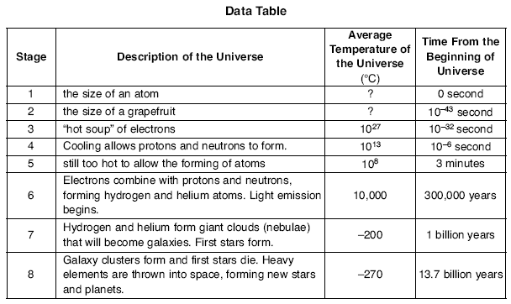
- The first atoms to form were __________________________________________________
Question: What needed to change in order for atoms to form (combining of electrons, protons and neutrons)?

Where is our evidence for this Theory?
- Energy created by this explosion ____________________ along with the matter.
This radiation has been traveling ________________________in the ____________ and __________________ over billions of years, but can still be measured and observed.
This original radiation is called: ________________________________________(CMB) which is long-wave ___________________ radiation that appears to be coming from everywhere in the universe!
- ____________________________ Exhibited by observing the spectrum of distant galaxies and stars over time.
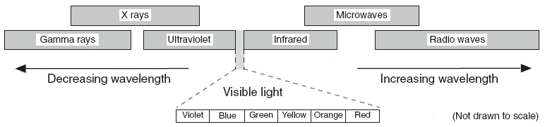
pg. 14 of your ESRT displays the electromagnetic spectrum, or all energy produced by the sun.
If we focus on visible light, Which colors have the longest and shortest wavelength?
__________________= longest wavelength
__________________= shortest wavelength

- Each ________________________in the universe emits energy in __________________________________
- The human eye observes ________________________________________of visible light in the form of ___________________
- We can look at the spectral signatures of stars and infer 2 things:
1.)_______________________________:which elements they are composed of
2.) If they are moving _____________________ or ________________from us (if the spectral lines shift position with time)
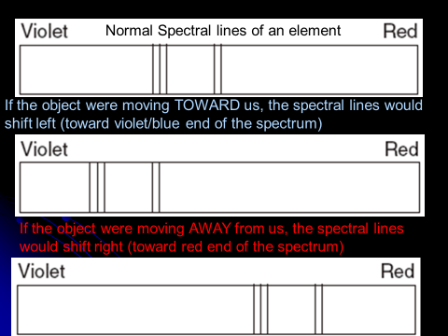
The Doppler Effect:
- The position of wavelengths (spectral lines), are shifted to either the
- ________________________
- ________________________
- Because the universe is ______________________________, objects that are moving ____________ from one another will cause the wavelengths of energy to ______________ or become _______________, causing what’s known as a __________________________________
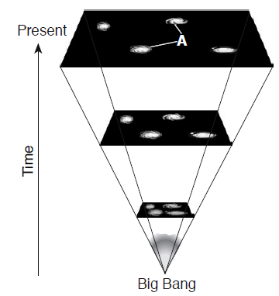
- MOST GALAXIES SHOW A ______________________
- The __________________________________will merge with ours in the future
  - It’s spectra is thus _________________________________ with time
- ______________________________ : States the Universe is Expanding!
- The ____________________________ it’s expanding, the greater the ________________________ (further the spectral lines are shifted in the spectrum)!
PART II: Galaxies
A Galaxy is:
- Stars and gases are held together by ________________________________
- An Average galaxy will have over _______________________stars
  - Each star (or two) with its own ______________________________________
- Estimated to be over _____________________________ galaxies in the universe!
The three types of galaxies are:
- Elliptical:
- Spiral:
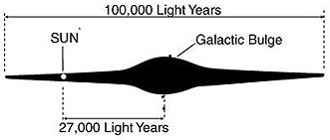
- Irregular:
Our Galaxy: ____________________________________________.
- We are a ______________________located on the ___________________of one of the galactic arms!

